Using the App to Manage Teams

Bowls Club App – Team lifecycle guide

Purpose: This guide explains how a team is created and maintained in the Bowls App, how fixtures are attached to that team, how availability is gathered, how players are selected and positioned, and how members are notified by the app and by email.

1. The People Involved
Role | How they are involved
Club admin | A club admin can maintain the wider club setup, including members, roles, venues, greens, teams and fixtures where permissions allow.
Fixture secretary | The fixture secretary normally creates and maintains fixtures for the season. This may include entering fixtures as soon as the fixture list is available.
Selector | A selector may review availability, select players, manage reserves and help shape the team for a fixture.
Team captain | A team captain may manage the team pool and help select players for fixtures involving that team.
Fixture captain | The fixture captain is the person responsible for an individual fixture. In this manual, this is the term used for the person managing selection, positions, publication, reminders and match-day changes for that fixture.
Team members | Team members are the players in the team pool. They can see relevant team fixtures, indicate availability, receive selection notifications and accept or decline once selected.
Terminology used in this guide: To keep the wording simple, this guide uses the term “fixture captain” for the person in charge of an individual fixture. In practice, club admins, fixture secretaries, selectors and captains may all be able to view and interact with teams and team fixtures, depending on their app permissions and club role.

2. Creating and Maintaining Teams
A team in the Bowls App is not just a static list of names. It represents a playing group that can be used across the season for availability, fixture planning, team selection, position allocation and communication.
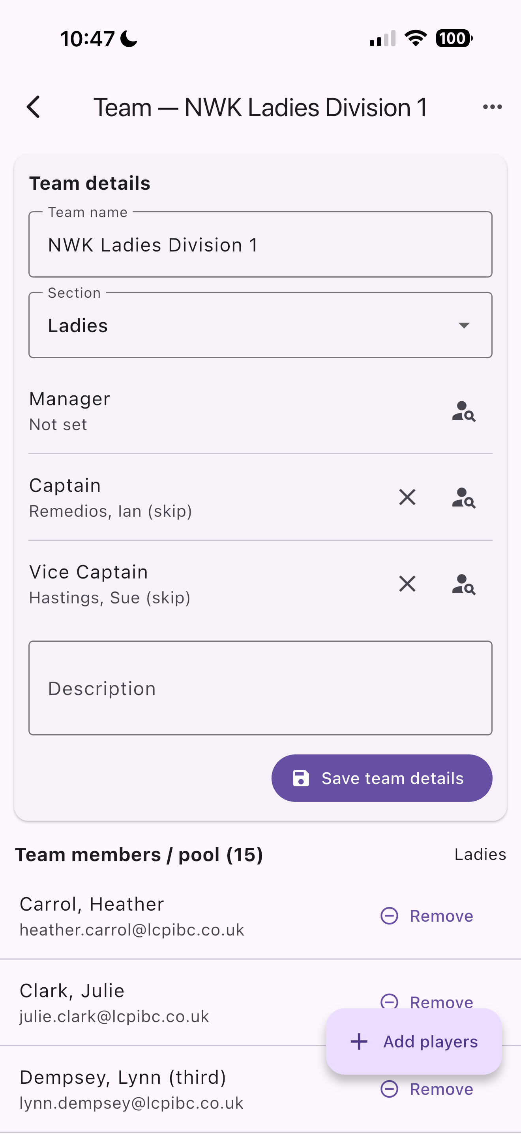
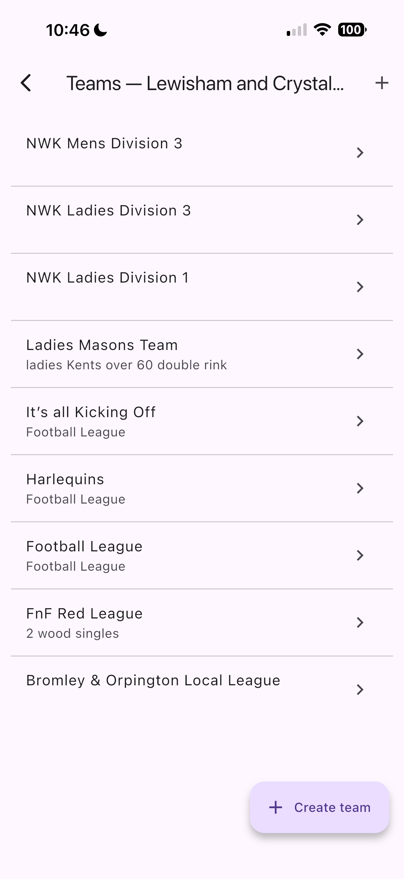
When a team is created, authorised officers can add members to the team pool. This pool should contain the members who would normally be considered for that team. The pool can be changed during the season as circumstances change.

Screenshot 1 - Team list Screenshot 2 - Team Pool
The Teams list shows the teams created for the club. The Team pool shows the members linked to a team. Members Authorized officers can open a team to maintain its can be added or removed as the season changes.

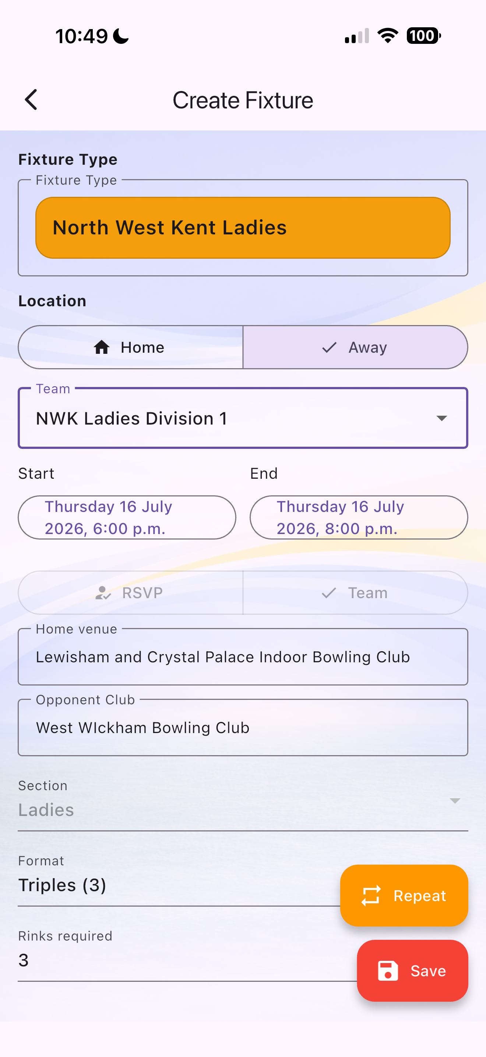
3. Creating Fixtures for the Season
Once fixtures are known, the fixture secretary or another authorised officer can enter them into the app. For team fixtures, the fixture is linked to a specific team.
This is one of the main advantages of the team process.
Fixtures can be entered as soon as the season list is available, and team members can then see those fixtures well before selection takes place.

Screenshot 3 - Create Team Fixture
A team fixture is linked to a specific team. Once created,
team members can see the fixture and register their availability.

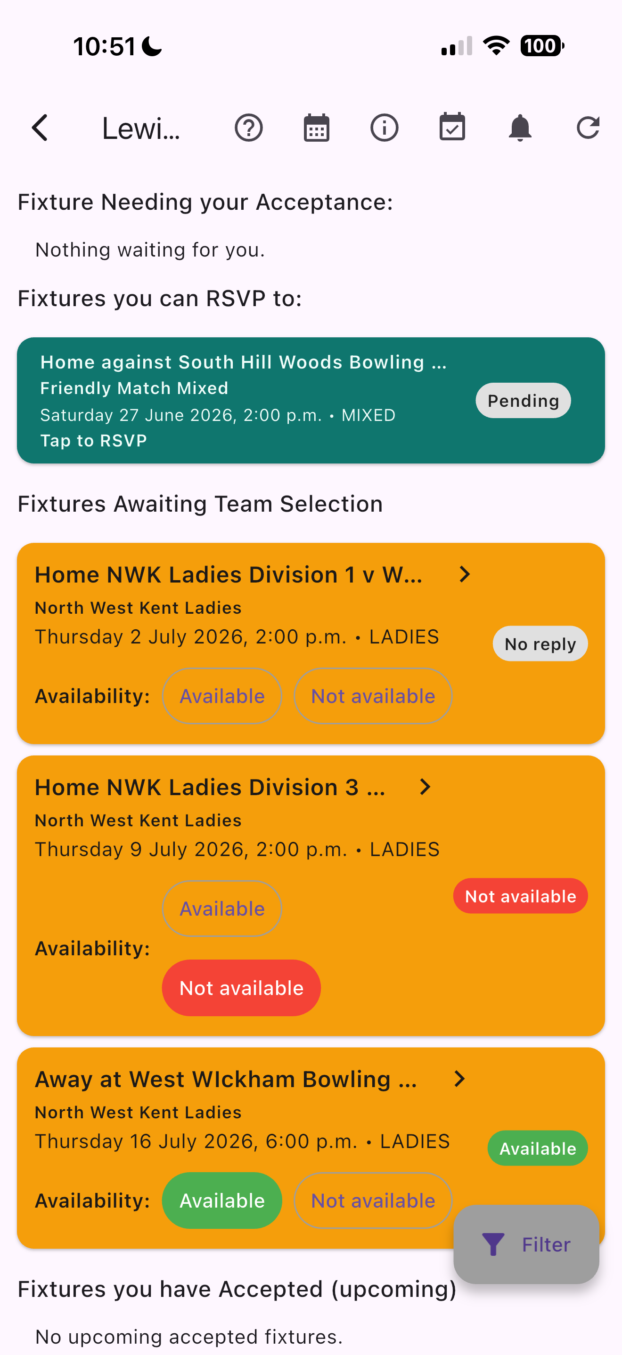
4. Availability Before Selection
Before anyone is formally selected, team members can indicate their availability. This gives the fixture captain early visibility of who can play, who cannot play and who has not yet replied.

Availability is especially useful because knowing who is not available is often just as important as knowing who is available. It allows the fixture captain to plan selection from reliable information rather than guesswork.

Screenshot 4 - Dashboard availability
Team members see team fixtures awaiting selection and can
mark themselves as available or not available.

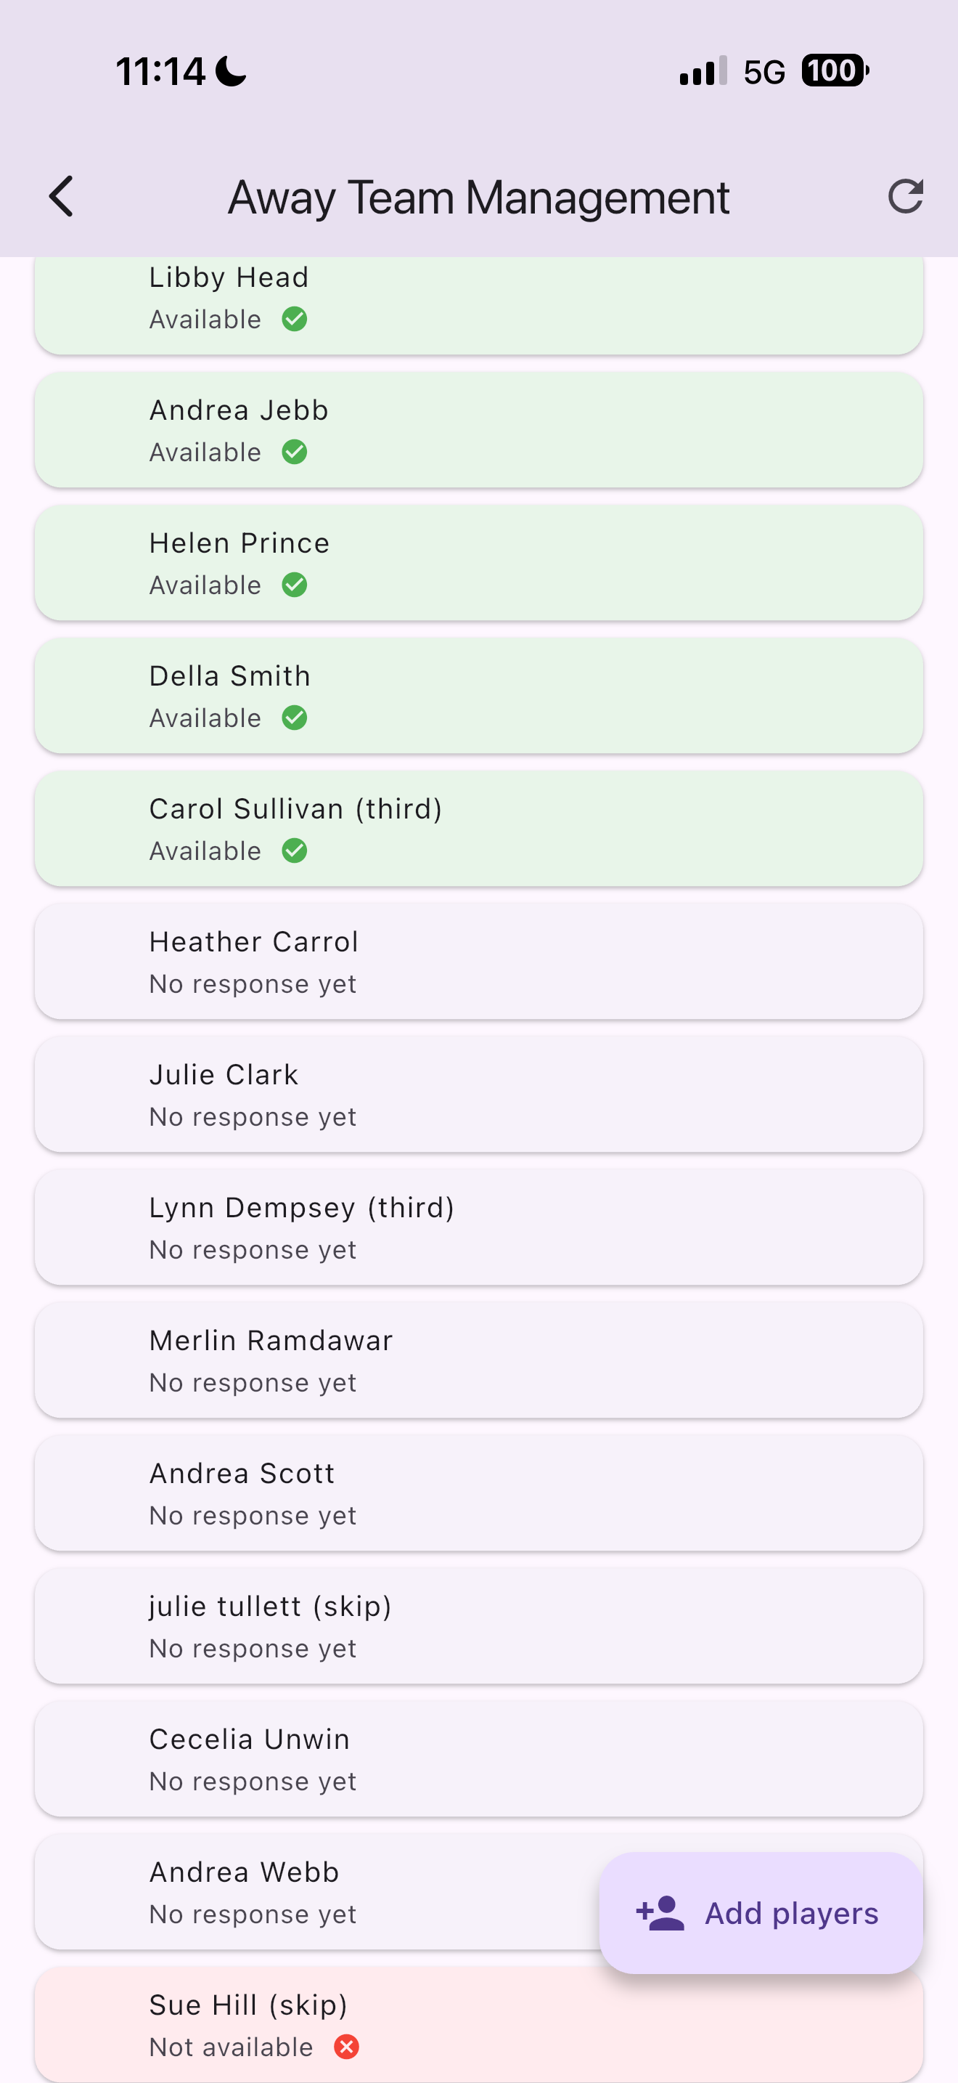
5. Selecting Players

The fixture remains unpublished while selection is being prepared. During this stage, the fixture captain can select players from the team pool, add other eligible players if needed, remove players, and identify reserves.

Because the team is not yet published, the fixture captain can make changes without confusing members or sending premature messages.

Screenshot 5 - Manage selection
The fixture captain can review the team pool, selected players,
reserves and availability responses before publishing the team.

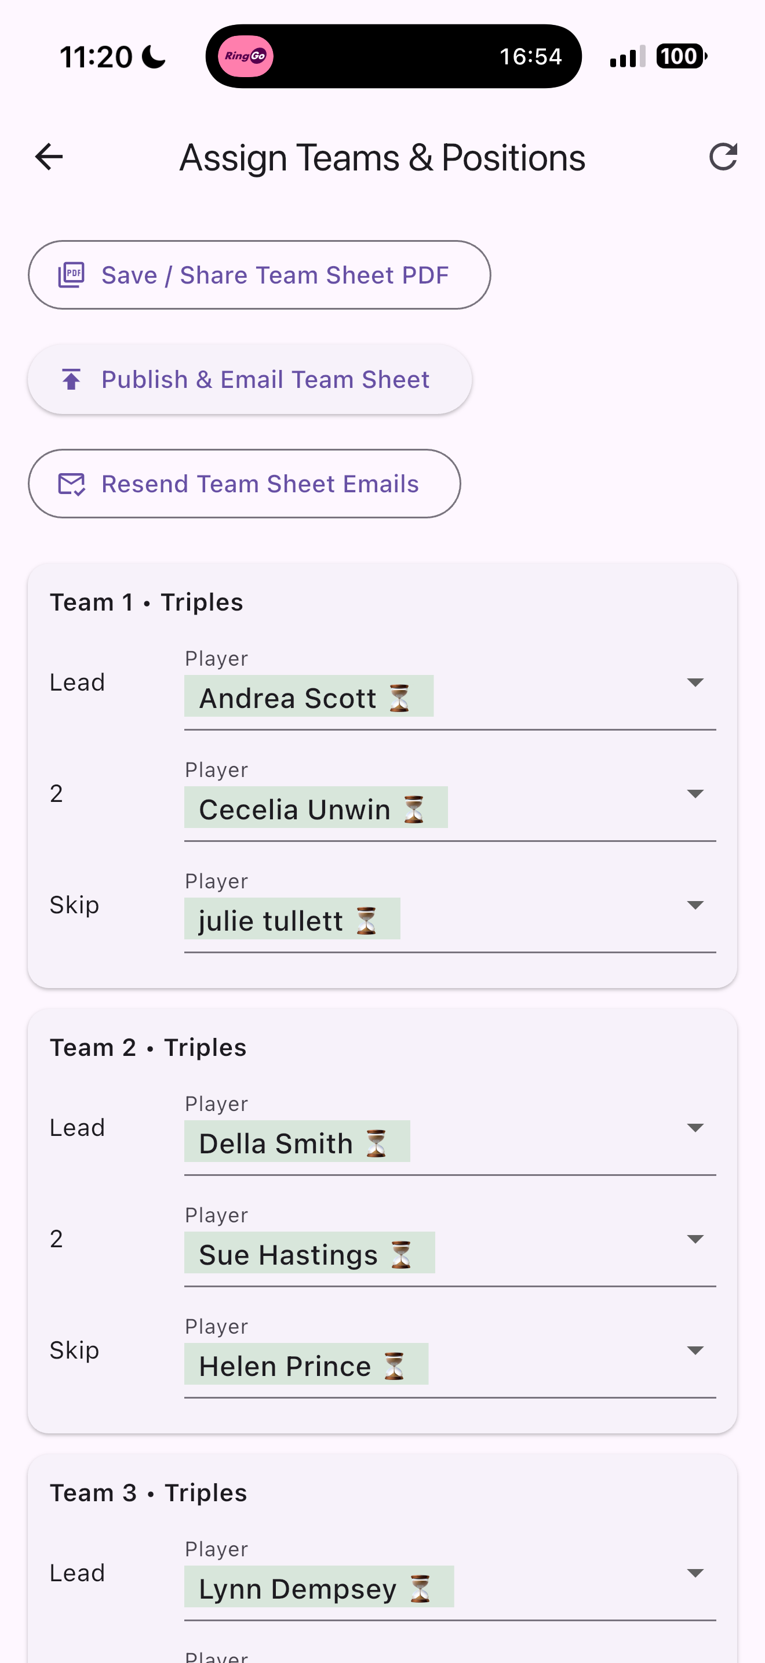
6. Allocating Positions and Teams

After players have been selected, they can be placed into their playing teams and positions. The format will depend on the fixture, such as pairs, triples or rinks.

The app separates team selection from physical rink allocation. This means the fixture captain can organise players into teams even if the final rink numbers are not yet known.

Screenshot 6 - Team / rink assignment
Selected players can be placed into teams and playing positions
according to the fixture format.

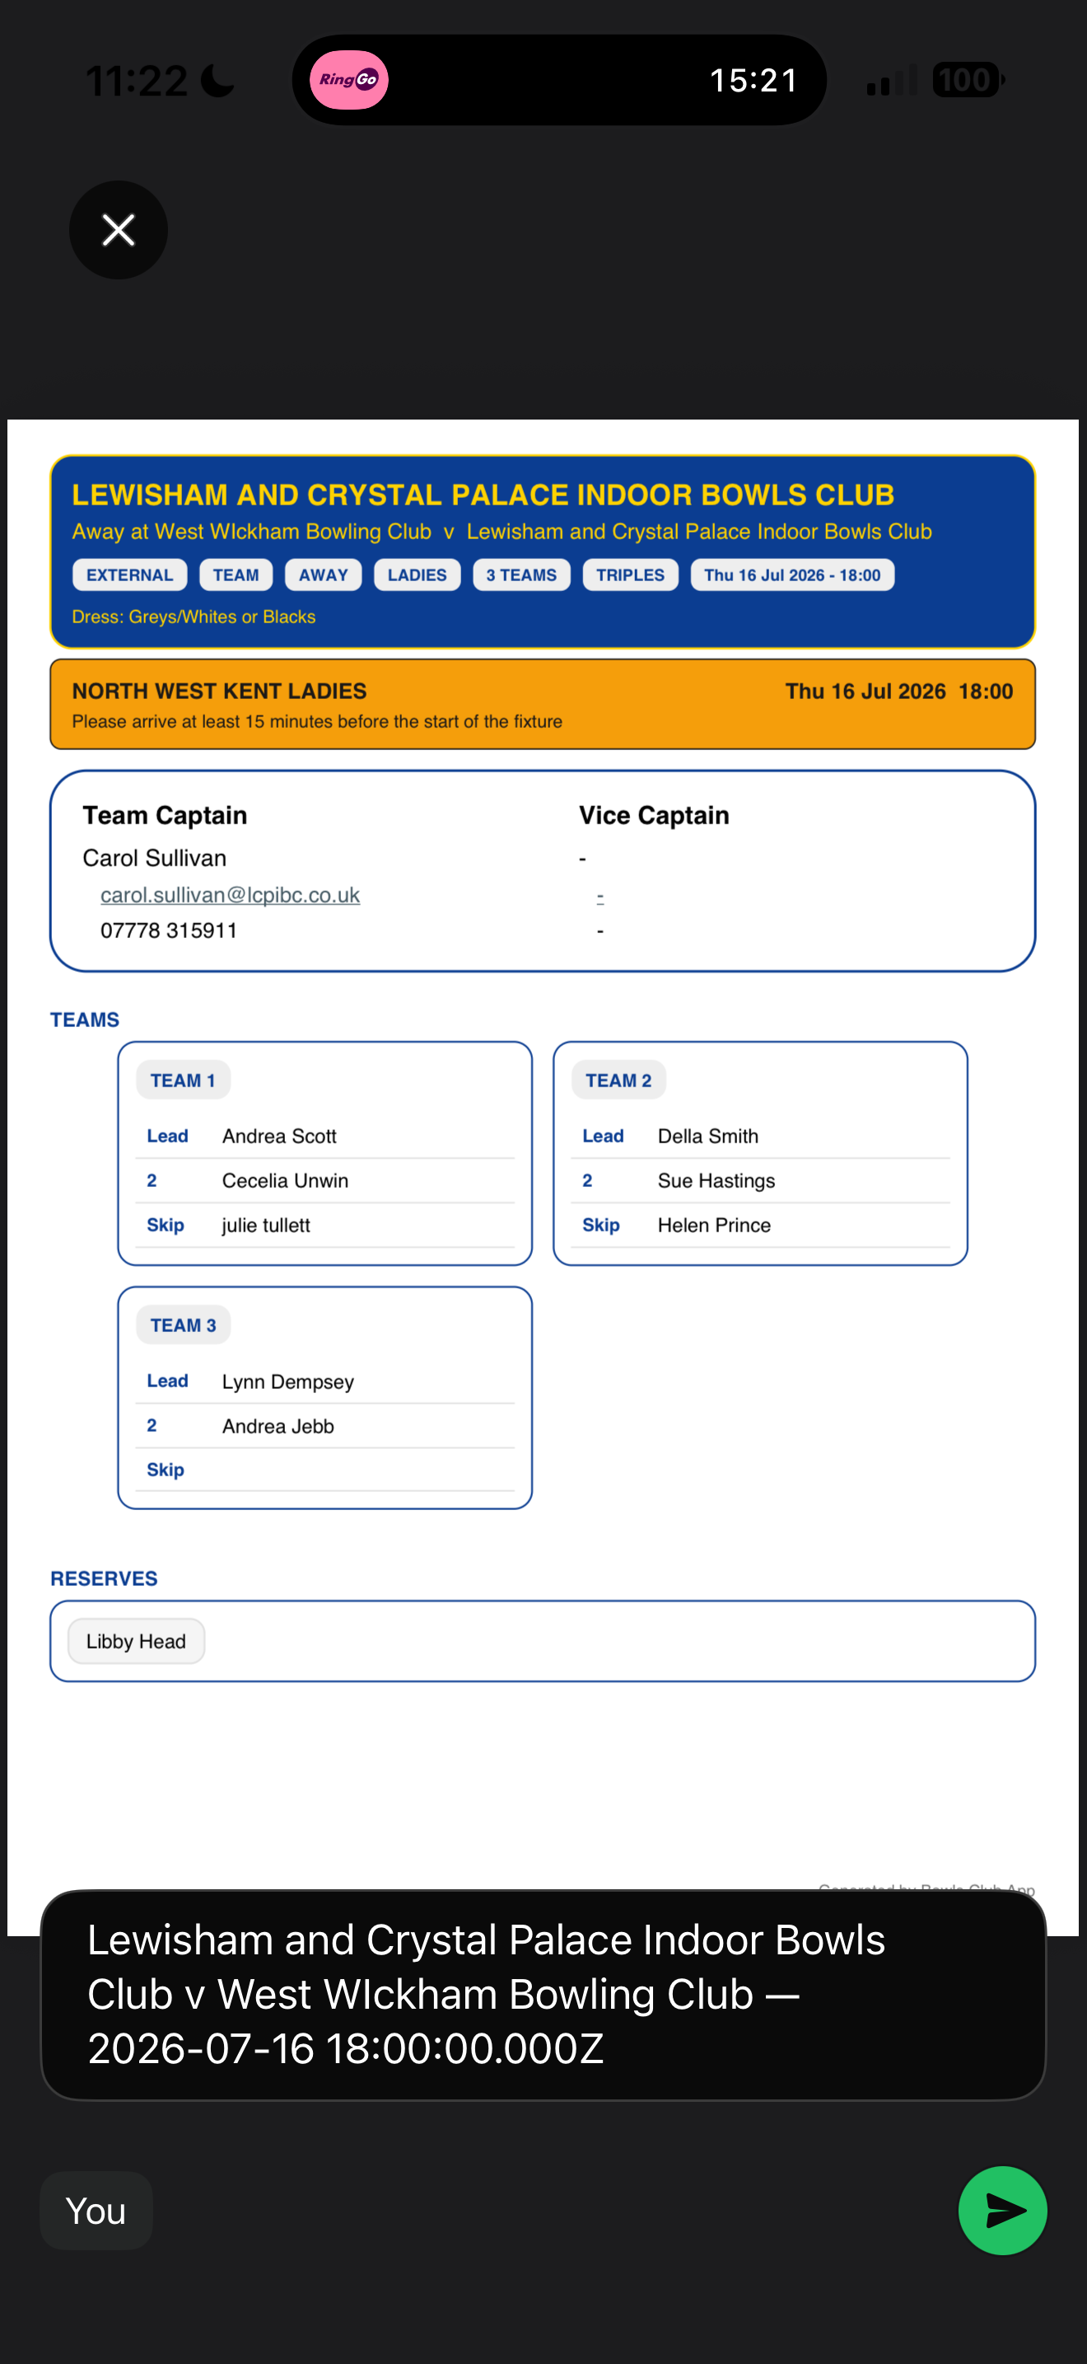
7. Publishing the Team

Publishing is the point at which the team is formally released to selected players. Once published, selected members can see the fixture on their dashboard and are asked to accept or decline their place.

When the fixture is published, selected members should also receive an email containing the fixture sheet. The fixture sheet shows the fixture details, team layout, playing positions, captain details, reserves and any rink information that has been entered.

Screenshot 7 - Fixture sheet / published team
The published fixture sheet provides selected players with the fixture details,
team layout, positions and reserves.

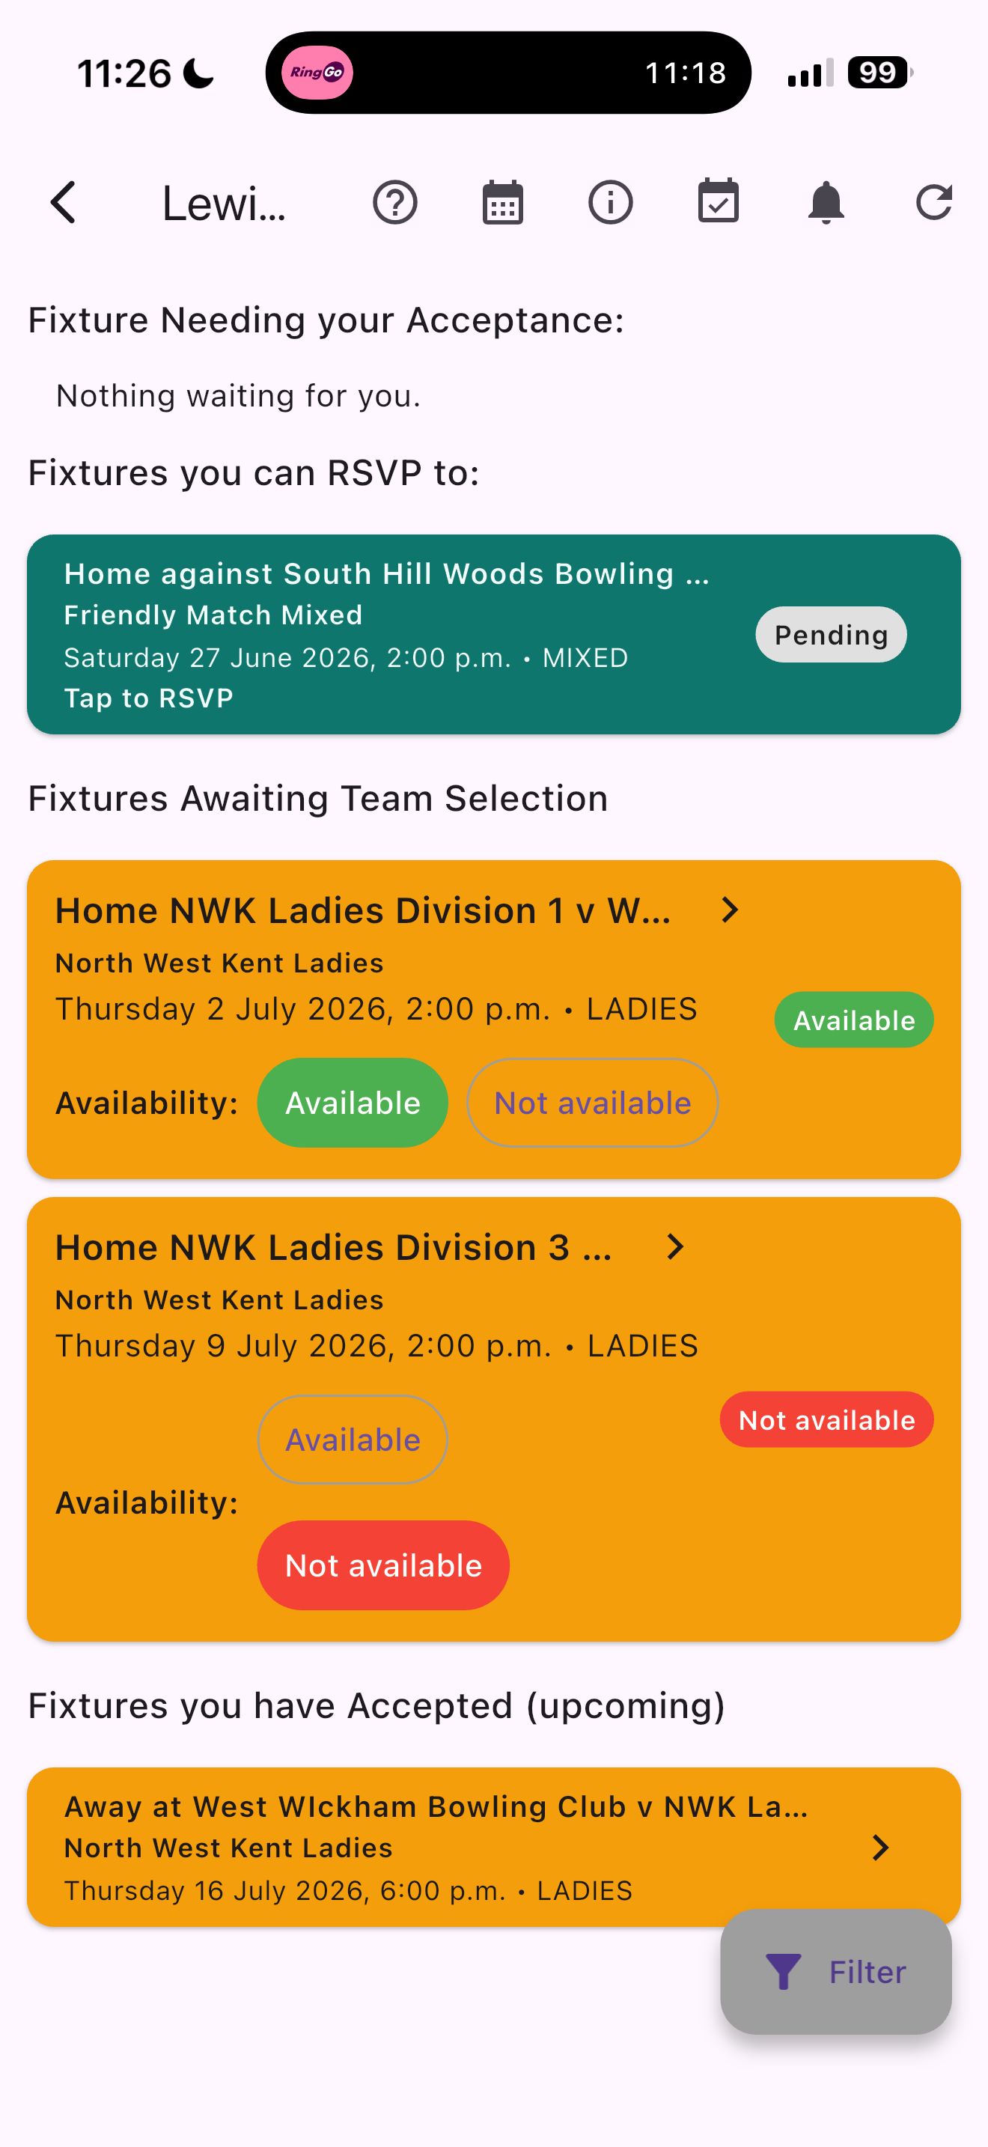
8. Member Acceptance and Dashboard Updates
After publication, selected members should open the fixture and accept or decline their place. If they accept, the fixture appears as an accepted upcoming fixture. If they decline, the fixture captain is notified so that a replacement can be arranged.
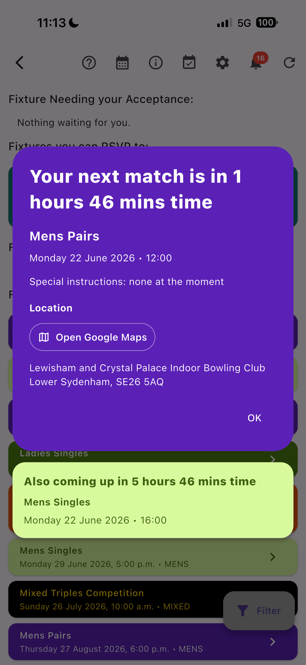
Members should check the dashboard regularly because it highlights fixtures needing attention, fixtures awaiting selection and accepted upcoming fixtures.

When you open the App if any fixtures have been accepted the next match will be displayed. If you have more than one a second match will be also displayed.
Screenshot 8 - Member dashboard after publication
The dashboard shows fixtures needing acceptance, fixtures awaiting selection and accepted upcoming fixtures.

9. Reminders and Communication
The app supports communication by both in-app notifications and emails to the member’s registered email address. Notifications and emails may be sent when a team is published, when a fixture sheet is issued, when a selected player has not replied, or when important fixture details change.
The fixture captain can also send reminders manually at any stage. This helps reduce missed replies and avoids the need to write separate messages to each player.

10. Changes After Publication
A published team can still change. A player may decline, become unavailable, or be moved from reserve to player. Positions, rink numbers, fixture times or venue details may also be updated.
Where important changes are made, affected members may receive further notifications or emails asking them to check the fixture again.

11. Why the Process Helps
The team lifecycle allows the club to enter fixtures early, gather availability before selection, prepare the team privately, publish the team formally, send the fixture sheet by email, collect player acceptance, monitor outstanding replies and issue reminders.
The aim is to reduce confusion, avoid missed messages and give fixture captains, selectors and players a clearer view of what is happening.

Team Lifecycle Summary
Stage | What happens | Outcome
1 | Team created | Team pool is created and maintained.
2 | Fixtures entered | Team fixtures can be loaded as soon as they are known.
3 | Availability gathered | Members indicate whether they are available before selection.
4 | Players selected | Fixture captain selects players and reserves while fixture remains unpublished.
5 | Positions allocated | Players are placed into teams and playing positions.
6 | Team published | Selected members are notified and receive the fixture sheet by email.
7 | Members respond | Selected players accept or decline their place.
8 | Reminders sent | The app and fixture captain can send reminders and updates.
9 | Match prepared | Accepted fixtures remain visible to members on their dashboard.

